SAP Application cluster validation

Prechecks

#pcs config show >> /tmp/pcs-config-08-11-25

#sestatus ==> its should be disable
#sysctl -a | grep -i net.ipv4.tcp_keepalive_time
net.ipv4.tcp_keepalive_time = 7200
#vi /etc/sysctl.conf
net.ipv4.tcp_keepalive_time = 300 ==>As per doc we need to add this line in below path
#sysctl -p
#cat /etc/sysctl.conf |grep -I keepalive time=300
#sestatus to check selinux disable or not its should be disable
#systemctl is-enabled corosync
#systemctl is-enabled pacemaker
#rpm -qa | grep -i resource-agents
#rpm -qa |grep -i azure -arm
#rpm -qa |grep -i fence

#cat /etc/hosts |grep -i by-dcoj2
#cat /etc/hosts |grep -i BYDE221OOD3
#cat /etc/hosts |grep -i BYDE221D9XS

#nslookup by-dcoj2

This both need comment it in fstab entry
#cat /etc/fstab
/usr/sap/OJ2/ASCS01
/usr/sap/OJ2/ERS11
Azure Console==>

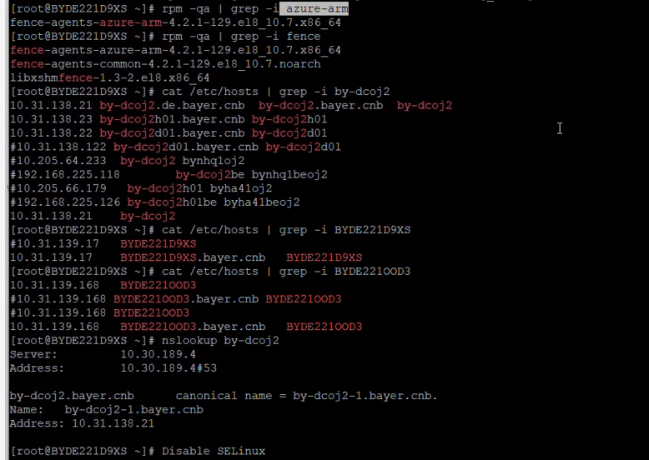

1.Take Os disks snapshot both primary and secondary.

2. load balancing- Need to modify below paramators both primary and secondary.
a. health prob--ascs-5, ercs-5, db-5,
b. loadbalance-rule--ascs-30 -enable, ercs-30 -enable, db-30 -disable

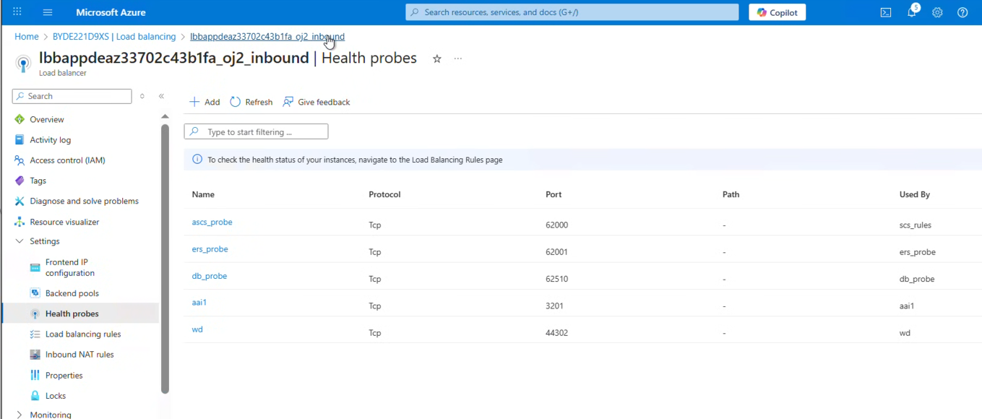

Parameters

#pcs property set maintenance-mode=false
#pcs cluster cib config.xml
remove line pcmk_delay_max from config.xml
#pcs cluster cib-push config.xml
#pcs resource defaults update priority=1
#pcs resource update rsc_sap_P69_ASCS01 meta priority=10
#pcs property set priority-fencing-delay=15s
#pcs resource update fs_P69_ASCS fast_stop=no
#pcs resource update fs_P69_AERS fast_stop=no
#pcs constraint remove location
or if its showing error
#pcs constraint location
#pcs constraint remove location-rsc_sap_OJ2_ASCS01
#pcs constraint location
#pcs constraint location rsc_sap_OJ2_ASCS01 prefers BYDE221SMDO=5000
#sudo pcs constraint order start g-OJ2_ASCS then stop g-OJ2_AERS kind=Optional symmetrical=false
#pcs constraint remove colocation-g-OJ2_AERS-g-OJ2_ASCS--INFINITY
#sudo pcs constraint colocation add g-OJ2_AERS with g-OJ2_ASCS -5000

Exampe
[root@BYDE221D9XS ~]# pcs constraint remove location
Error: Unable to find constraint - 'location'
[root@BYDE221D9XS ~]# pcs constraint location
Location Constraints:
Resource: rsc_sap_OJ2_ASCS01
Constraint: location-rsc_sap_OJ2_ASCS01
Rule: score=2000
Expression: rsc_sap_OJ2_ERS11 eq 1
[root@BYDE221D9XS ~]# pcs constraint remove location-rsc_sap_OJ2_ASCS01
[root@BYDE221D9XS ~]# pcs constraint location
Location Constraints:
[root@BYDE221D9XS ~]# pcs constraint location rsc_sap_OJ2_ASCS01 prefers BYDE221D9XS=5000
[root@BYDE221D9XS ~]# pcs constraint location
Location Constraints:
Resource: rsc_sap_OJ2_ASCS01
Enabled on:
Node: BYDE221D9XS (score:5000)
[root@BYDE221D9XS ~]#

Testing Need to follow word document

SAP database cluster validation

======================================================================
Paramators
#crm config show >> /tmp/crm-config-08-11-25

>put cluster in maintenance mode before updating the parameters

#crm configure property maintenance-mode=true

>set priority fencing delay 15 sec

#crm property set priority-fencing-delay=15s

>for splint end scenario set property priority-fencing-delay as 30

#crm configure property priority-fencing-delay=30

>configure azure events using following commands

#crm configure delete cln_azure-events

#crm configure property node-health-strategy=custom

#crm configure location loc_azure_health /'!health-.*'/ rule '#health-azure': defined 'uname'

#crm configure primitive health-azure-events ocf:heartbeat:azure-events-az \

#meta failure-timeout=120s \

#op start start-delay=60s \

#op monitor interval=10s

#crm configure clone health-azure-events-cln health-azure-events \

#meta allow-unhealthy-nodes=true

>change the node name before executing the following commands

#crm_attribute --node BYDE221NBDI --name '#health-azure' --update 0

#crm_attribute --node BYDE221YYX4 --name '#health-azure' --update 0

>remove cluster from maintenance mode

#crm configure property maintenance-mode=false

